NEWS RELEASE
Supporting the concrete contractor as the voice and recognized authority for the residential concrete industry since 1974.

P.O. Box 204
113 1st Street NW
Mount Vernon, Iowa 52314

(319) 895-6940

www.cfawalls.org
For more information call:
Jim Baty at 319-895-6940
E-mail: jbaty@cfawalls.org

FOR IMMEDIATE RELEASE
May 8, 2015
Note: Editors, images selected for these projects can be downloaded from http://ge.tt/9VGsP1G2?c.

2015 PROJECTS OF THE YEAR HAVE BEEN ANNOUNCED BY THE CONCRETE FOUNDATIONS ASSOCIATION
Mount Vernon, Iowa—Following evaluation by the industry and general public during the World of Concrete and online at www.cfawalls.org, the Concrete Foundations Association (CFA) has announced the recipients for the 2015 Projects of the Year.
The awards will be presented publicly during CFA Convention 2015, to be held in Williamsburg, Va. July 23-25. Among the projects receiving recognition this year are three residential foundations, an above-grade concrete home and a college educational facility.
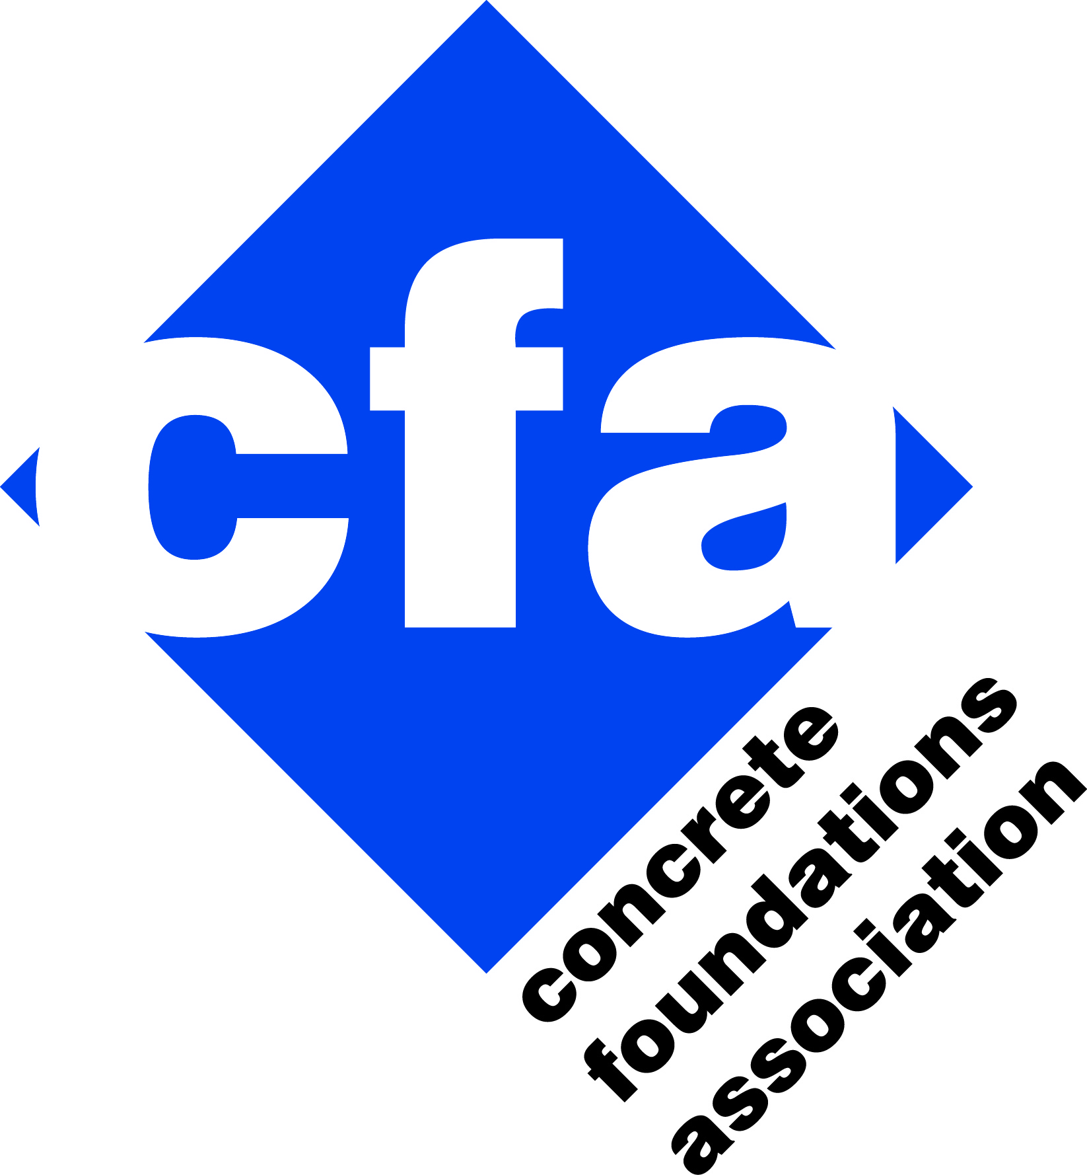
“Projects of the Year” is a competition held annually by the CFA to increase the recognition of the substantial challenges faced and met by today’s professional cast-in-place concrete contractor. Projects are awarded by category and one project is selected as the “Overall grand project.”
“It is clear the markets across this country have been increasing as the number of entries to this program are increasing,” stated Jim Baty, executive director for the CFA. “What is even more impressive is the growth of types of projects submitted including apartment complexes, educational buildings and even a fire station along with another great year of challenging foundations.”
Categories for the competition include foundations for single-family residences split into three sizes (less than 2,000 square-feet, between 2,000 and 5,000 square-feet and greater than 5,000 square-feet), above-grade concrete homes, and commercial/multi-family structures. Projects submitted this year once again represent a broad cross-section of the continental U.S. According to Baty, the submissions represent the broadest cross-section of construction being designed and constructed by CFA members.
[… press release has been truncated to only include 1 of the 5 winners … ]
Above-Grade Concrete Home
Since the start of the new millennia, the recognition of performance and aesthetic advantage for all concrete homes has been a focus for the CFA and many throughout the concrete industry. Over the years, many fine works of construction and design have been recognized in this award category. Certainly no less impressive is this year’s “Above-Grade Concrete Home Project of the Year,” Clifton Concrete Home by Bartley Corporation.
“We were selected for this project when several recommendations for this type of complex structure pointed our way,” stated Jim Bartley, president of Bartley Corporation. “The construction manager hired for the project desired to partner with us based on our previous experience in building a concrete home.”
Bartley was asked about what makes this type of a project such a challenge. “Working with owners, construction managers and architects as well as other trades that are new to concrete homes can be a major time commitment,” stated Bartley. “Meeting on site and collaborating with the entire team was the key to success. Having an architect that saw the project all the way through construction made everything go as planned."
Prior to the kickoff meeting the homeowners wanted to see a sample of the normal cast-in-place wall finish, one delivered on any foundation project. Bartley built and poured the mockup and made sure it wasn’t “perfect.” To their surprise the owners loved the bug holes, imperfections, ties and form-lines. They are in the building industry and like the industrial construction look with natural imperfections. Therefore, extreme measures were taken to avoid using any patching materials on the walls. With the exception of one or two spots honeycombs were avoided. Surprisingly, a crew patched one of these honeycomb regions and when the homeowners saw the patching they asked that it be removed. This kept the project on track and consistent with the approved aesthetic negotiated early in the project.
Another unique characteristic of this design was the presence of two different insulation systems, Thermomass and ThermaEZE, both products that the company had prior experience but separately on projects. The standard wall section consisted of two reinforcement bar mats, Thermomass in the center with all the connectors, conduits, block outs and wall ties. However, where the weight of steel could not bear on insulation, the ThermaEZE system was brought in to provide an alternative support system. All walls were to be left exposed concrete as the final interior and exterior finish.
The most complex part of the project was the first and second floor walls. Gang forms were used to provide the large structural walls and Bartley engaged their commercial crew and a full time commercial superintendent to take the lead in these areas. Difficult block outs and forming along with many recesses for utilities, electronics and built-in features had to be as accurate as possible. Further complicating these walls was the flashing detail. The design called for flashing between the second floor and roof deck to cover the inside of the wall through to the Thermomass insulation sandwiched in the center of the wall. Although Bartley preferred to approach the design with a monolithic roof and second floor based on their experience, the design called for flashing to separate this interface into separate placements with flashing installation between.
Some of the other challenges faced on the project included unique window jambs and an elevator shaft. Many of the windows called for the sides of the window block out to be at 105-degrees rather than perpendicular to the face of the wall. The 3-story elevator shaft challenged the safety on the jobsite with openings that were constantly managed. The shaft was produced by first forming the outside of the elevator shaft and then, when the walls were ready to be closed, a crane carefully placed large interior panels on the inside of the wall.
For more information on this foundation project, contact CFA Member Jim Bartley, Bartley Corporation, at jim@bartleycorp.com or (301) 384-2700.

[… press release has been truncated to only include 1 of the 5 winners … ]

Each year, the CFA “Projects of the Year” offers a challenging competition to the industry. This publicizes the craftsmanship and creativity of the cast-in-place concrete industry that largely goes unnoticed or unseen. It is free to CFA members and brings to light the quality and accomplishments that happen daily in the concrete industry, many which become quickly covered never to be recognizable or appreciated within the final product.

More Information
For more information on these projects, visit the “CFA Projects of the Year” at http://www.cfawalls.org/awards/project/index.html where you will find more images and facts for this year’s winners, the historical archives for the competition and information on the competition itself including voting basis and entry guidelines.
If you would like more information, please contact Jim Baty at the CFA. Phone 866-232-9255 or jbaty@cfawalls.org.

The CFA is a voluntary, nonprofit association that brings together concrete contractors and professionals nationwide to improve the quality of cast-in-place concrete walls and foundations. The CFA provides promotional materials, educational seminars and networking opportunities to its members and the industry. CFA also works on behalf of its members and the entire industry to develop support and influence code bodies. For more information about CFA, please visit www.cfawalls.org or call 866-CFA-WALL (232-9255).

# # #

